Fulltone Festival Stall Booking Information
If you are interested in booking a stall at the Fulltone Music Festival on 20th July 2019 please complete our initial enquiry form below. Pitch fees are listed below. Please note that a discount is available for Devizes-based businesses and will be confirmed upon booking.
Fulltone Music Festival would like to discourage the use of single use plastics wherever possible. We will look more favourably on stall holders who share this ethos and use alternatives such as wooden cutlery or vegware and are becoming more environmentally friendly about their packaging.

Prices for stalls
There is a variety of different pitches, and fees have been calculated according to size. Please see below for definitions of pitches.
- Suitcase stall – £10
- Charity – £20
- Trade (small) – £60 (Max 3mx3m)
- Trade (Large) – £120 (Max 3mx6m)
- Trade (XL) – £200 (Max 3mx9m)
- Hot Food (small) – £130 (Max 3mx3m)
- Hot Food (Large) – £170 (Max 3mx6m)

Suitcase Stalls
These are aimed at small scale sellers with a particular focus on local makers offering unique and individual products. We particularly like to support start up businesses. Stalls are limited to MAXIMUM 1m x 1m. Please note there will be no cover for suitcase stalls so traders should bring their own parasol or golf umbrella and a table if required. Gazebos are not permitted for suitcase pitches.

Charity stalls
Charities are offered a stall at the Festival at a reduced rate. These are limited to a 3m x 3m plot. Power will not be provided. Please bring your own gazebo as needed. Please contact us if you need more than a single pitch.

Trade stalls
Trade stalls are aimed at arts and craft retailers, or those selling cold food (cakes, meats, cheeses etc) and hot drinks. We do not provide power. Please bring your own gazebo as needed.

Hot food stalls
These are for those aiming to provide hot food or drink. Power can be provided, but please ensure this is requested on your application form and we will contact you separately. Please bring your own gazebo as needed.
Stalls can be set up from midday and can leave the site at 6pm.

Trade and hot food stalls only:
If you need space for a vehicle (no bigger than a Transit van), we will charge an additional £60. We encourage you to bring your own generators if you need electricity; please ensure they are quiet and don’t give out lots of fumes. Limited power points are available for an additional £5 per day (limited to 16Amps).
Drink and food stalls can be set up from the morning and can close at 10pm – this will also encourage maximum profit for your pitch.

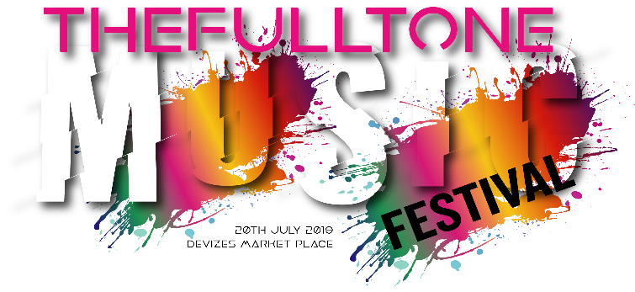

Fulltone Music Festival initial enquiry form

Saturday 20th July 2019
Please be advised that we will send you a full application based on the information you provide on this form. We try to ensure what is offered at our events is high quality and that we do not have a number of stalls selling the same goods. However, we cannot offer exclusivity.
- Name *
- Telephone *
- Email address *
- Website or other social media (Facebook, twitter, etc) *
- Type of stall *
Suitcase Charity Trade Hot food
- Please describe your stall - What will you be selling? *
- Is your stall (select all that apply): *
Ethical Fair trade Using local produce Organic None of the above
- What efforts are you making to reduce your use of single use plastics? *
- Fulltone Music Festival is committed to reducing the use of single use plastics at our events and encourage all of our market traders to do the same.
Devizes is a Fairtrade town
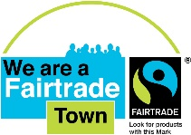
Please email to jemmaroberts@hotmail.com once completed

